Barcoding Protocol
last updated by Katie Pearson on June 19, 2019
Goals: This protocol describes how to barcode specimens independently of any other digitization steps.
(Some content adapted from the Florida State University barcoding protocol by Austin Mast)
- Determine where you most recently left off barcoding by looking at the cabinet logs taped to the front of the herbarium cabinets (see pages 2-3). The last barcoded cubby will be indicated by initials and a date under the word “Barcoded” on that cubby, while the following cubbies in the diagram will not have initials or a date under “Barcoded”.
- Remove all the specimens from the next cubby to be barcoded. Bring this cubby of specimens to your barcoding workstation.
- Place the first/next specimen on a level surface by itself.
- Apply a barcode 1/8 inch (NO CLOSER) from the bottom left corner of the first specimen (see image below).
  - DO NOT apply a barcode sticker on top of anything else (e.g., herbarium stamp, piece of the specimen, or a label).
  - If there is not space in the bottom left corner, place the barcode somewhere else along the bottom of the specimen. If there is not space at the bottom of the specimen, you may use the top edge of the specimen.
  - If a sheet has an indication that there are two different species on a single sheet, set this sheet aside and notify a supervisor, making sure to record the folder in which the specimen had been filed (Supervisor: see note at end)
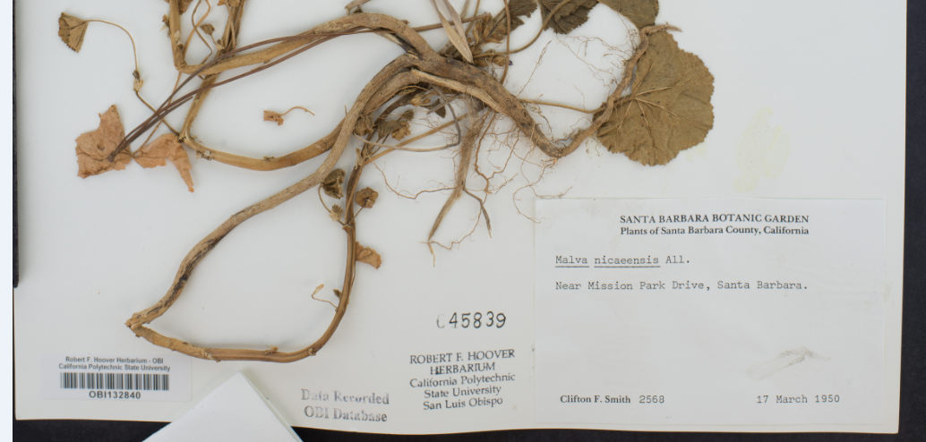
- Repeat steps 3 and 4 for every specimen in the stack
- Put away the cubby of specimens. Write your name and the date under the word “Barcoded” on the corresponding cubby on the cabinet diagram.
- Obtain a new cubby of specimens, keeping track of your progress on the cabinet diagram taped to the outside of the cabinet.

Supervisor notes:
Specimens with multiple specimens on a single sheet should be barcoded once for every specimen on that sheet. Then, when imaging, one image will be taken for each barcode on that sheet (i.e., 3 barcodes = 3 identical images, each with a different image name corresponding to one of the barcodes on the sheet).
Note that the program we are using to rename images at the time of imaging, Smart Shooter 3 will not be able to automatically name specimens with multiple barcodes on the sheet! Therefore, during imaging, the technicians should make a note of which barcodes belong to this anomalous specimen, they will have to manually rename the images accordingly.
Specimens that consist of multiple sheets or items should be treated as a set of botanical duplicates, with each sheet or item receiving its own barcode. Each sheet or item should then have a corresponding record in the database.

Cabinet Log
For collections that barcode and image specimens in separate steps
A copy of this document (or the half-cabinet version on the next page) should be printed and attached to the outside of each cabinet in the collection.
Cabinet Number: ___________
1. Barcoded | Imaged | 14. Barcoded | Imaged
2. Barcoded | Imaged | 15. Barcoded | Imaged
3. Barcoded | Imaged | 16. Barcoded | Imaged
4. Barcoded | Imaged | 17. Barcoded | Imaged
5. Barcoded | Imaged | 18. Barcoded | Imaged
6. Barcoded | Imaged | 19. Barcoded | Imaged
7. Barcoded | Imaged | 20. Barcoded | Imaged
8. Barcoded | Imaged | 21. Barcoded | Imaged
9. Barcoded | Imaged | 22. Barcoded | Imaged
10. Barcoded | Imaged | 23. Barcoded | Imaged
11. Barcoded | Imaged | 24. Barcoded | Imaged
12. Barcoded | Imaged | 25. Barcoded | Imaged
13. Barcoded | Imaged | 26. Barcoded | Imaged

Completely imaged and frozen: _________________________Date:_____________

Cabinet Log (half-cabinet version)
For collections that barcode and image specimens in separate steps
1. Barcoded | Imaged | 8. Barcoded | Imaged
2. Barcoded | Imaged | 9. Barcoded | Imaged
3. Barcoded | Imaged | 10. Barcoded | Imaged
4. Barcoded | Imaged | 11. Barcoded | Imaged
5. Barcoded | Imaged | 12. Barcoded | Imaged
6. Barcoded | Imaged | 13. Barcoded | Imaged
7. Barcoded | Imaged | 14. Barcoded | Imaged

Completely imaged and frozen: _________________________Date:_____________

