Protocol for Associating Barcode Numbers with Accession Numbers
last updated by Katie Pearson January 20, 2020
  - Goal: This protocol describes how to update your old accession number with the specimen’s new barcode number. You can do this only after you have uploaded specimen images to the iDigBio server and linked them to your database in CCH2.
- Log in to your CCH2 account and click My Profile on the right side of the menu bar.
- Click the Specimen Management tab.
- Click the name of the collection that you will be imaging.
- In the Data Editor Control Panel, click Edit Existing Occurrence Records.
- In the Record Search Form, click the Processing Status field and select “Unprocessed” from the dropdown menu.
- In the Custom Field 1 field, select Other Catalog Number from the first dropdown menu and IS NULL from the second dropdown menu.
- Click the “Display Editor” button.
- Locate the accession number (the stamped number, rather than the barcoded number or the collector number) on the specimen in the image to the right of the Occurrence Editor form (screenshot below). You can zoom in by pressing Command (Mac) or Control (Windows) and clicking on the image where you want to zoom in. Alternatively, you can hold Shift, click on the area where you want to zoom in, and move the mouse up (to zoom in) or down (to zoom out).
- Enter the accession number, without leading zeros (e.g., if the number reads “0145”, you will enter “145”), into the Other Cat. #s field (circled below).

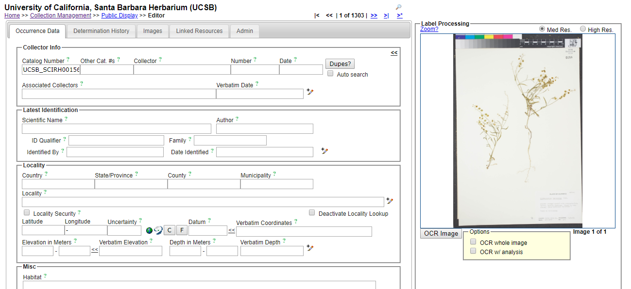
- Click outside of the Other Cat. #s field (or press the Tab button). A message should show up under the “Dupes?” button. Make sure that your browser’s pop-up blocker is disabled so you can see these messages.
- If the message shows “No Dupes Found” (see below):
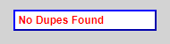
  - Check that the specimen sheet is not stamped “Databased” or has any other indication that it SHOULD have a record in the database. If it is, try adding a leading zero to the accession number and repeat step 9.
  - Press the Save Edits button (or press Tab and Enter on your keyboard)
  - Move on to step 11.

- If a pop-up window shows up that says “Record(s) using the same identifier already exists. Do you want to view this record?”:
  - Click OK.
  - Check that the identified duplicate does not already have an image associated with it (if it does, you will see a bold barcode number on that record). If the duplicate does have an image already, close the window, scroll down to the Processing status field in the Curation box, select “Expert Required” from the dropdown menu, and then click the Save Edits button. Otherwise, move to step c.
  - Check that the data of the identified duplicate matches the data on the label of the specimen image you were viewing. You need not check every field, just two or three important fields such as Scientific Name, Collector, and Locality.
  - If the data match up, click “Merge Records” and exit the duplicate window. If the data do not match up, close the window, scroll down to the Processing status field in the Curation box, select “Expert Required” from the dropdown menu, and then click the Save Edits button.
- Click the double arrow icon at the top right corner of the occurrence editor.
- Repeat steps 8-11.
- When you are done with your shift, make sure to log out of your account and close the browser window.

