Instructions for Uploading Snapshot Data to CCH2
Last updated by Katie Pearson on February 19, 2019

Goals: This document describes how to upload an entire database “snapshot,” which will not be managed live, into CCH2.

- Log in to your account in the CCH2 portal, click “My Profile,” navigate to the “Specimen Management” tab, and click the name of the institution for which you are uploading data.
- In the Administrator Control Panel, click “Import/Update Specimen Records.”
- In the dropdown list of options, select “Saved Import Profiles.”
- Click the button next to the appropriate upload procedure. If you are not sure which upload procedure to use, or if no upload procedure is visible, contact the project manager.
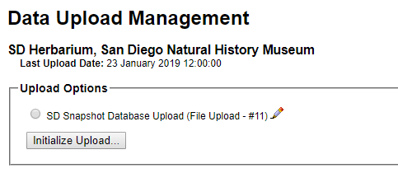
- Click the Initialize Upload... button.
- Click the Choose File button and select the CSV file containing your database records.
  - NOTE: It is important that the CSV you are trying to upload has the same fields (i.e. column names) as the first CSV you loaded using this upload profile. Consider saving a CSV export template on your computer for future comparison.
- In the “Source Unique Identifier / Primary Key” field, select “accession_id” from the dropdown menu. The mapping for your CSV file will then appear below.

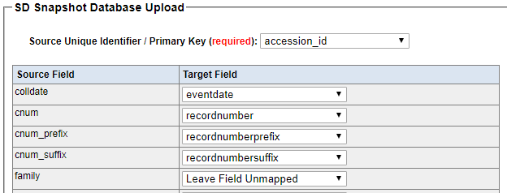

- Make sure that all of the Source Fields (left column) have been matched up with a Target Field (right column). Unmatched fields will be highlighted in yellow. If you see any yellow fields, contact the project manager or data manager about how to proceed.
  - Some fields will be selected as Leave Field Unmapped. This is because CCH2 autofills that field or otherwise accounts for the field indirectly.
- Select your desired Processing Status from the dropdown menu at the bottom of the page.
  - The Processing Status field is mostly useful for institutions that manage their collections live in CCH2. You will likely choose the “Leave as is / No Explicit Setting” option for this reason.
  - The CAP TCN uses “Pending Review” for all specimen records that have been entered but not double-checked by a supervisor or other trained observer, and “Reviewed” is for specimen records that have been transcribed and double-checked by a supervisor or trained observer.
- Click “Start Upload.” You will be taken to a page that will update periodically while CCH2 ingests your data. Do not navigate away from this page until you see the message “Record upload complete, ready for final transfer and activation” (see below).
  - NOTE: Your data have not been uploaded to CCH2 yet! Your records are now stored in a temporary table where they can be reviewed before being transferred to the central table.
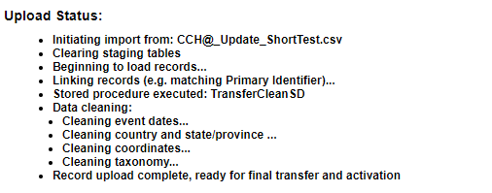
- To view the records to be uploaded before they are transferred to the central table, click the table icon to the right of “Occurrences pending transfer: ##” (circled below). Scroll through the records and make sure that the data have been transferred to the appropriate fields and that no extraneous symbols have been added to your data fields due to conversion issues (this often happens if the file has been transferred from a Mac to a PC or vice versa).
  - If you are not satisfied with the resulting table, you may need to make changes to the CSV input file or the field mapping. Feel free to contact the project manager or data manager should you have any issues with the mapping.
  - If you make changes to the CSV input file, you will need to start over from step 2.
  - Pay attention to the warnings provided in the Pending Data Transfer Report box (example shown below). The provided information should help you determine whether your new data upload will produce the intended result.

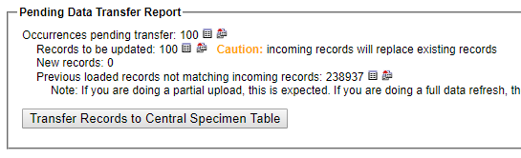

- Once you are satisfied with how your data have been imported into the temporary table, click the “Transfer Records to Central Specimen Table” button. This action is final and cannot be reversed!

