Exploring Herbarium Specimens Online

Learning Objectives
- Use an online database to search and explore biodiversity specimen data
- Interpret biodiversity information from historical specimen labels
- Identify flowers and fruits on herbarium specimens and make inferences about plants’ flowering and fruiting times

Introduction

What are herbarium specimens?
An herbarium is an organized collection of dried, pressed plant specimens that have been collected for scientific study. Each herbarium specimen is carefully mounted to a sheet of archival paper, and a label is affixed to the paper that describes where, when, and by whom the plant was collected. The label often includes information about the habitat in which the plant was found, what other species were in the area, and what the plant looked like before it was pressed.
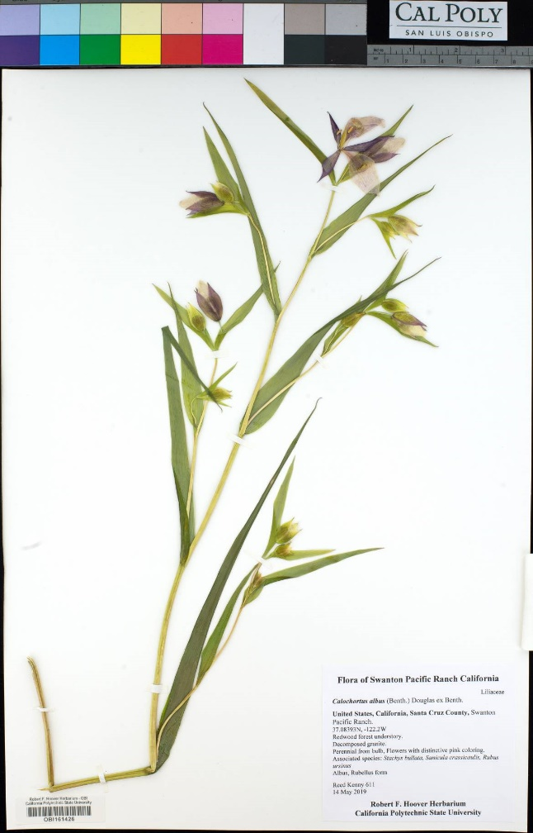
Left: An herbarium specimen collected by a graduate student as part of a floristic inventory. Right: Close-up image of the specimen label.

Where are herbarium specimens?
Herbarium specimens are stored in large cabinets and carefully maintained by curators, collections managers, and, often, volunteers and students. (For a sneak peek inside an herbarium, watch this video: https://www.cpalms.org/Public/PreviewResourcePerspectivesVideo/Preview/166547). There are over 3000 herbaria worldwide, holding over 390 million herbarium specimens and counting. You can find an herbarium near you by visiting this site: http://sweetgum.nybg.org/science/ih/.
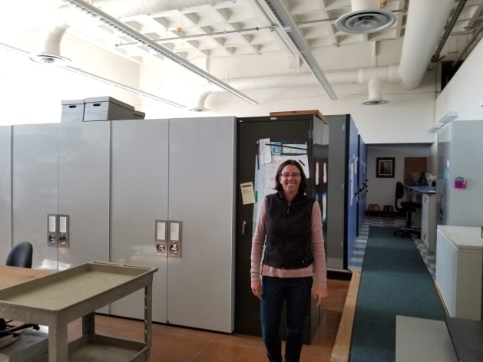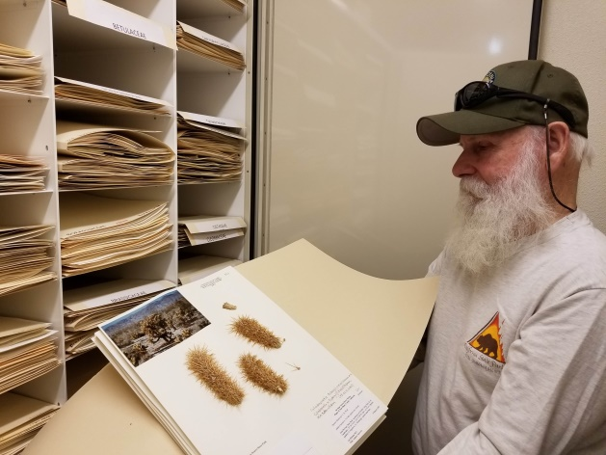
Left: Layla Aerne Hains, collections manager of the San Diego Natural History Museum, stands in front part of their herbarium. Right: Larry Hendrickson, botanist for the Colorado Desert District of the California Department of Parks and Recreation, displays a cactus specimen in the herbarium at Anza-Borrego Desert State Park
More recently, herbarium specimen data can also be found online through databases of “digitized” specimens. Thanks to efforts by faculty, staff, volunteers, and students like you, millions of specimens have been photographed and made available in databases such as iDigBio (https://www.idigbio.org/), GBIF (https://www.gbif.org/), and CCH2 (http://cch2.org/).

Why do we collect herbarium specimens?
Herbarium specimens are critical to our understanding of where and when plants occur, what they look like, and how they might be changing with changes in climate and land use. For example, scientists have discovered that plant populations in California have been shifting to higher elevations over the past 100 years, likely driven by a warming climate (Wolf et al. 2016). Maps of plant distributions, field guides that you can use to identify plants, and scientific illustrations of plant species are all produced in part from herbarium specimen data.

How to Find Information and Herbarium Data Online:
There are many online portals full of herbarium specimen data (for example, idigbio.org, gbif.org). In this activity, we will be using the Consortium of California Herbaria database, CCH2, which contains specimens from herbaria in California. This is where the Cal Poly Hoover herbarium curates its specimen data.
- In a web browser, go to cch2.org.
- To search for specimens of a specific species, click the Search Collections tab. See the next page for a screenshot.
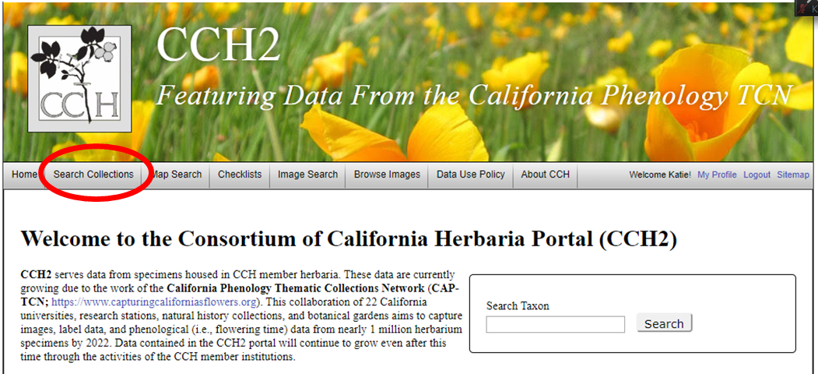
- Make sure that the Select/Deselect All button is checked and click the Search button.
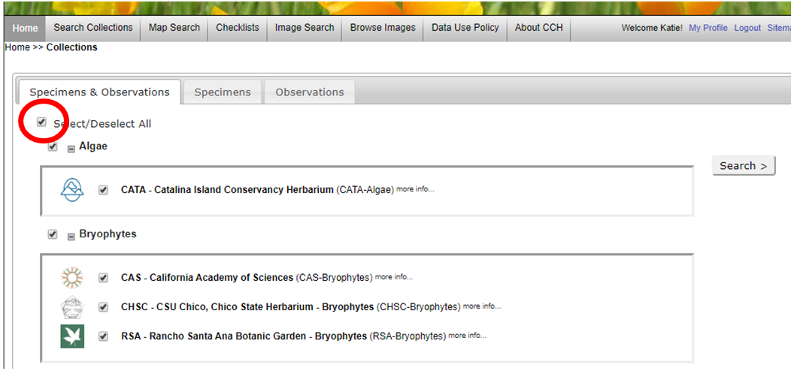
- On the next page, you can enter the parameters for your search of the herbarium database. Enter the name of your species in the Scientific Name field, then click the List Display button to view the results of your search.
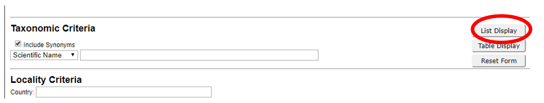
- To view an individual specimen in your search results, click Full Record Details or the thumbnail image of the specimen. There you can also view a larger version of the image by clicking Open Large Image below the thumbnail.
- To make a map of your specimen records click on the map tab.
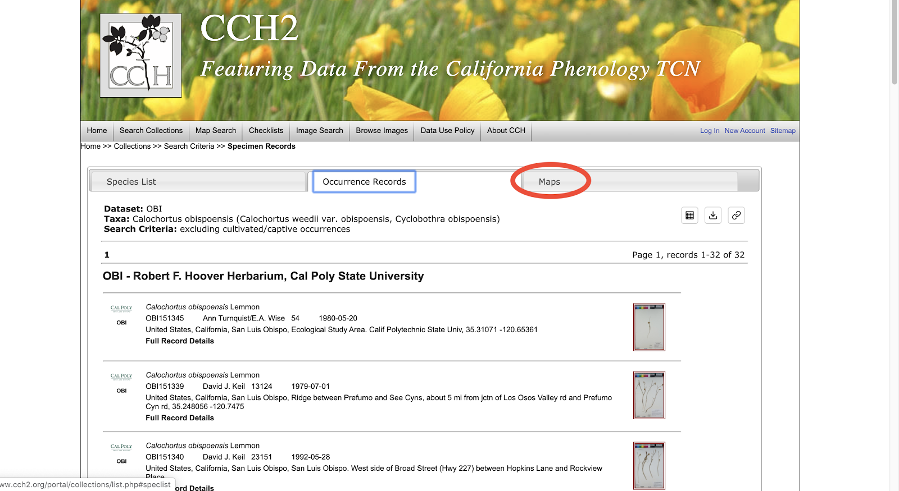
- Click on Display coordinates in Google Maps to view all your points on the map!
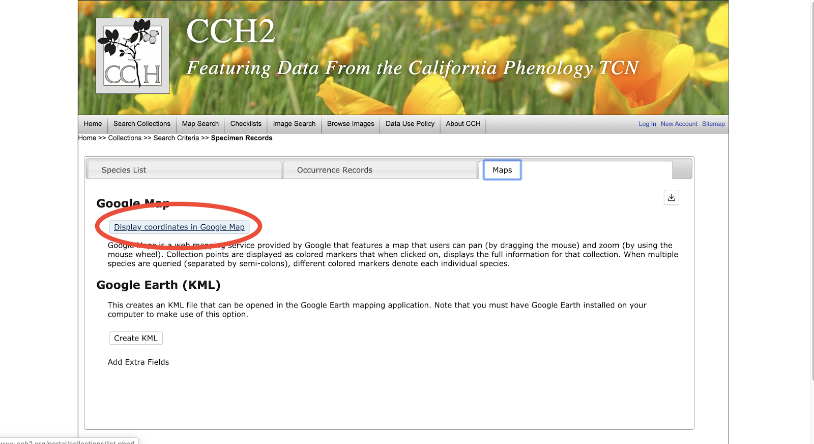
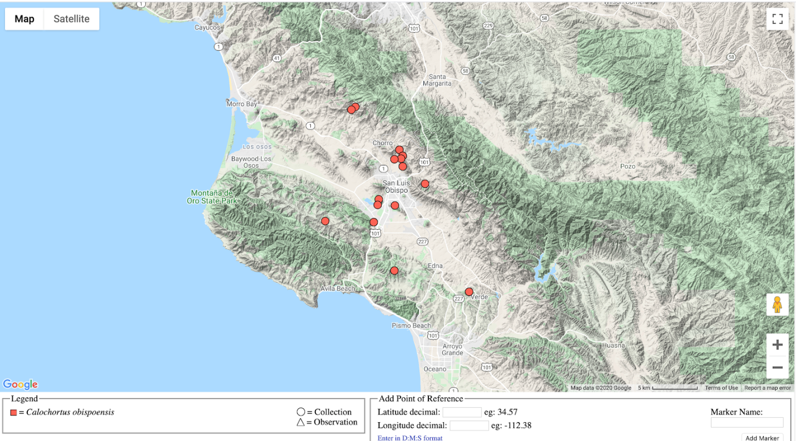
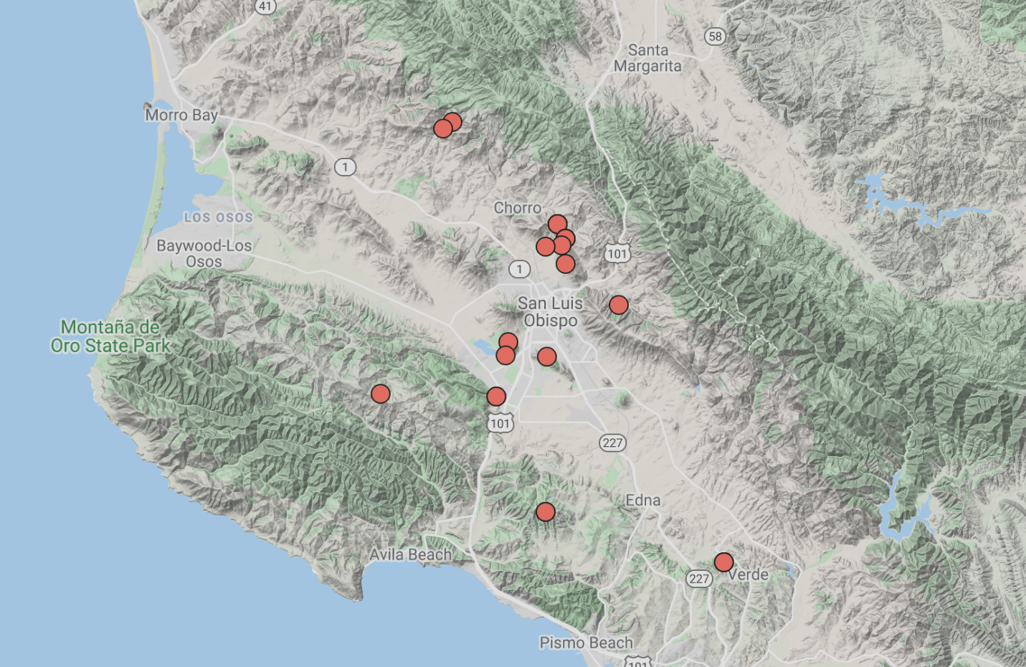

Exercise Questions
Select one of the species from the list below.
Lupinus microcarpus
Lupinus bicolor
Eschscholzia californica
Corethrogyne filaginifolia
Lupinus nanus
Acmispon strigosus
Eucalyptus globulus
Trifolium willdenovii
Solanum xanti
Sambucus nigra subsp. caerulea

Using the search functions as described above, find 20 herbarium specimen images for the species that you have selected. Complete the table and answer the questions below.
Fruits are reproductive structures that develop from flowers and may take many forms. To determine what the fruit looks like for your taxon, you may want to do an internet search for your species along with the word “fruit”. For example, searching “Solanum xanti fruit” results in images like the following:
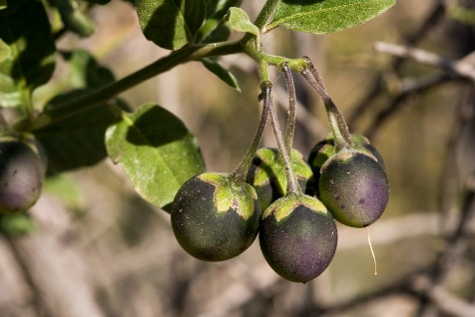
Note that flowers and fruits on herbarium specimens often look much different than flowers and fruits in pictures or in person. Below is an example of a Solanum xanti fruit on an herbarium specimen. Notice how much smaller and less round it appears!
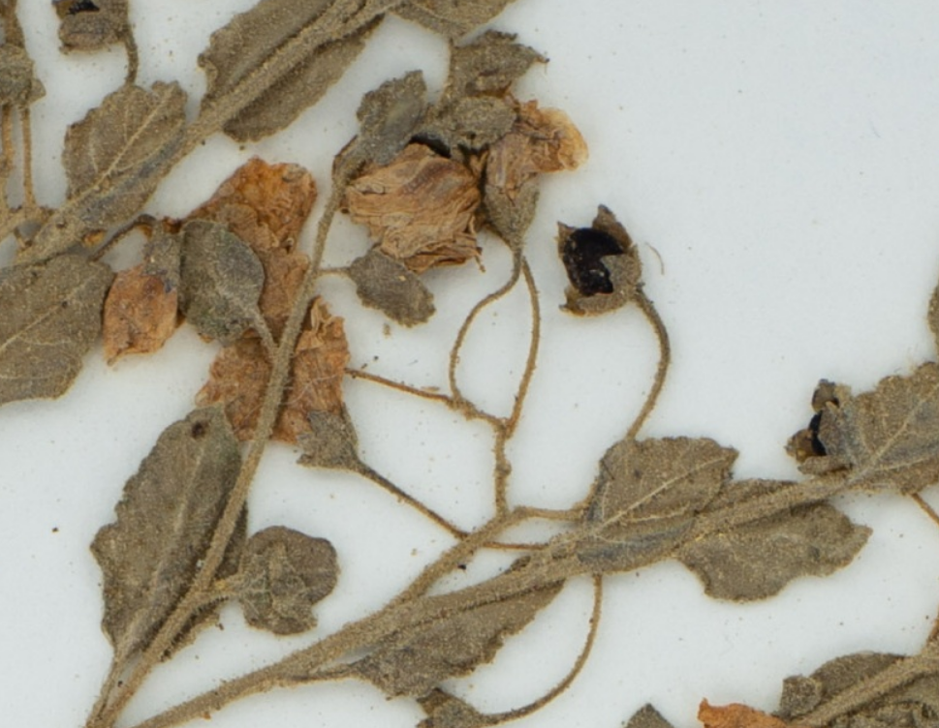
Specimen number | Flowers Present (y/n) | Fruits Present (y/n) | Date Collected (YYYY-MM-DD)
1
2
3
4
Specimen number | Flowers Present (y/n) | Fruits Present (y/n) | Date Collected (YYYY-MM-DD)
5
6
7
8
9
10
11
12
13
14
15
16
17
18
19
20
- Which species did you select?

- Follow the instructions above to make a map of your species’ collection locations. Add a screenshot of your map here:

- Based on the map of the localities of the herbarium specimen collections, describe the range of your species.

- It is useful if researchers can find the exact location where a specimen was collected based on the collectors’ location descriptions. Copy and paste (click Full Record Details) an example of one of the location descriptions from a label of specimen that would be detailed enough for you to find that location.

- Copy and paste one of the location descriptions that think you would not be able to find.
- Find the oldest specimen. What year was it collected? (Hint: click the Table button in the top right corner of the search results. Then in the Sort Results box, select Sort By: Event Date in Ascending Order).
  - Who collected it?
  - Where was it collected?

- Is there any crucial information missing from the label on the herbarium sheets? Transcribe (copy the text of) an example of one label that is missing crucial information.

- What percentage of the specimens you examined have flowers (use your table to calculate)?

- What percentage of the specimens you examined have fruits (use your table to calculate)?

- Did you see any differences in plant morphology (e.g., leaf shape, flower size, stem width, etc.) between the different specimens of your species? Are all the leaves the same size?
- Variation (presence of fruit or flowers, leaf size, etc.) on the herbarium sheets should correlate with the time of year that the specimens were collected. Based on the chart you made, in what month are most of your specimens flowering and in what month are most of your specimens making fruit (remember: a fruit is a mature ovary, which develops from the flower)?

References
Wolf, A., Zimmerman, N. B., Anderegg, W. R. L., Busby, P. E., & Christensen, J. 2016. Altitudinal shifts of the native and introduced flora of California in the context of 20th‐century warming. Global Ecology and Biogeography, 25(4):418-429. doi: 10.1111/geb.12423

