Imaging Setup Checklist

- Turn on lightbox and camera
- Remove lens cap
- Set focus mode to AF (autofocus)
- Create new folder on desktop
- Obtain specimens (fill out cabinet log)
- Start imaging log entry
- Open Smart Shooter 3
- Connect camera
- Check settings (they should match below)
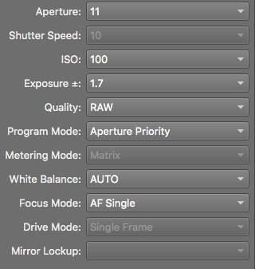
- Set image directory to your new folder
- Set name policy to [S]

Now you’re ready to (1) load your first specimen, (2) set the focal point, and (3) start imaging!
Make sure you set the focus to manual (M) on the camera once you have set your focal point!

